Solar Farm Land Proposal

NY, Newfane - 5604 Ide Rd

Prepared for Jonathon Pettitt

March 2, 2022

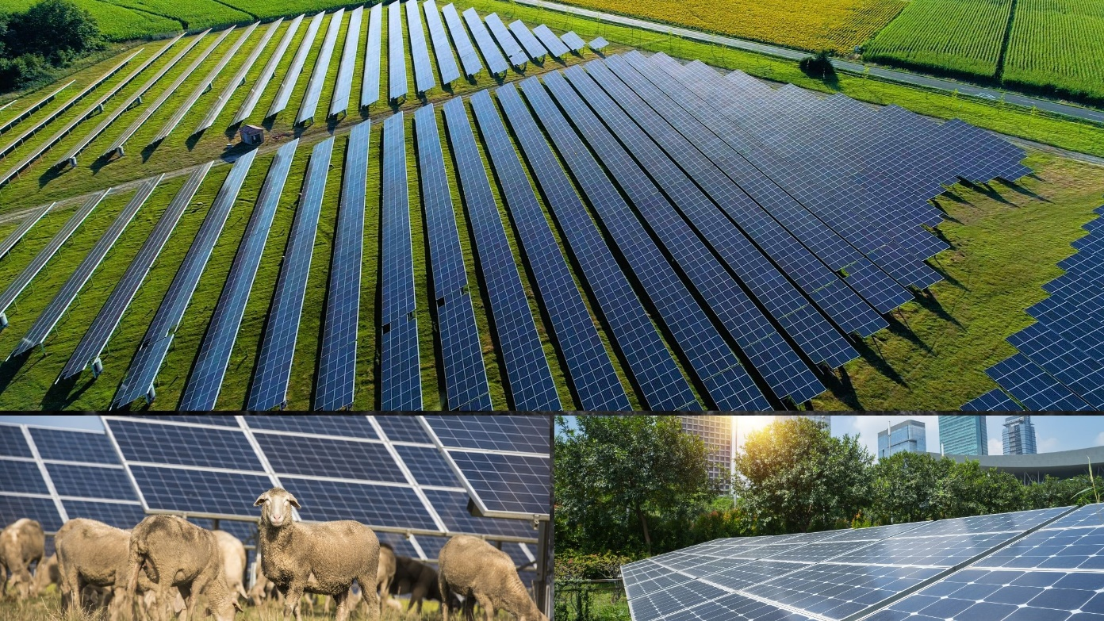

Hamza Khalil
Real Estate
Cipriani Energy Group
h.khalil@solrealgroup.com
O +1 855-786-4383 x111

Summary

Your parcel is located near a National Grid power line that appears to have capacity for us to develop a solar farm. This capacity will decrease or be lost if another project is built on the same circuit. Since you expressed some initial interest, this proposal will provide you more detailed information. We will be happy to answer any additional questions you may have so that you can make an informed decision with confidence and trust.

Cipriani Energy is interested in purchasing or leasing acreage from you. Typically we require a minimum of 5 acres and in the case of your parcel, up to 0.5+/- of your 32.8 acres.
Our normal process works like this:
- We give you this Proposal, you decide if lease or purchase is best for you and we finalize pricing.
- We provide you a formal agreement contract with a 2 week window to review it with your attorney if you desire.
- Contract is signed and an Option Fee is paid to you.
- We then have 12 months to obtain all required permits to build the solar farm. If for any reason we feel we cannot use your property, we terminate the contract and you keep the Option Fee.
- Once all permits are obtained, if the acreage is being purchased, we complete any necessary subdivision, at our cost, execute the purchase option, close on the purchase and pay you the remainder of the purchase price. If we are leasing your land, we execute the lease option and begin making the periodic lease payments.

Additionally, you can earn an extra $500 dollars with our referral bonus program (landowners that you know they may be interested) If we lease or purchase your referral's land.

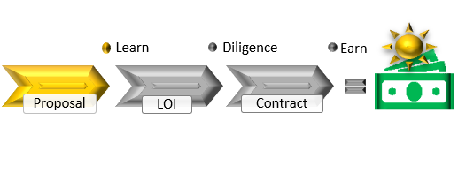

Details

Address: 5604 Ide Rd, Newfane, NY
Tax ID: 38.00-1-62.12
Acreage Needed: 0.5+/- of 32.8 acres
Contingencies: Buyer shall have 12 months to conduct due diligence on the property to ensure the property meets the requirements for their intended use.
Option Fee: $2,500 credited towards the lease or purchase price. Or forfeited by Buyer or Tenant if property is not sold or leased
Purchase:
- Purchase Price Amount: $3,000 per acre
- Buyer shall survey and subdivide as necessary at Buyer's cost.
- Real Estate Broker Fee: None.
Lease:
- Lease Price Amount: $1,250 per acre per year
- Tenant shall survey at Tenant's cost.
- Annual Rent Increase: 1.5 % per year
- Lease Term: 25 year(s) with two (2) extension options of 5 years each.
Because the available capacity to build this project can be reduced or lost if another project is built on the same circuit, it is preferable that you take action as soon as reasonably possible. We look forward, in collaboration with you, to the successful pursuit of New York State’s renewable energy goals and building something our grandchildren will be proud of.
Kind Regards,

Hamza Khalil
Real Estate
Cipriani Energy Group
h.khalil@solrealgroup.com
O +1 855-786-4383 x111
M

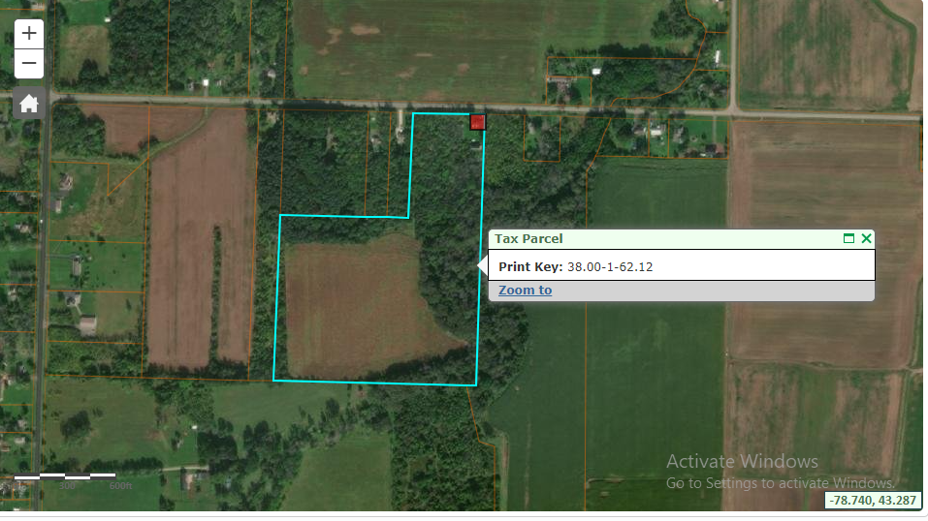

PARCEL LEASE ESTIMATE
 | $1,250 | $/Ac/Yr1
 | 0.5 | Acres
 | 1.5% | Escalator
 | $2,500 | Option Fee
 | two (2) | Five year | Extension Option
Yr | Rate per Ac | RENT
1 | $ 0.00 | $ 0.00 | At Execution
2 | $ 0.00 | $ 0.00
3 | $ 0.00 | $ 0.00
4 | $ 0.00 | $ 0.00
5 | $ 0.00 | $ 0.00
6 | $ 0.00 | $ 0.00
7 | $ 0.00 | $ 0.00
8 | $ 0.00 | $ 0.00
9 | $ 0.00 | $ 0.00
10 | $ 0.00 | $ 0.00
11 | $ 0.00 | $ 0.00
12 | $ 0.00 | $ 0.00
13 | $ 0.00 | $ 0.00
14 | $ 0.00 | $ 0.00
15 | $ 0.00 | $ 0.00
16 | $ 0.00 | $ 0.00
17 | $ 0.00 | $ 0.00
18 | $ 0.00 | $ 0.00
19 | $ 0.00 | $ 0.00
20 | $ 0.00 | $ 0.00
21 | $ 0.00 | $ 0.00
22 | $ 0.00 | $ 0.00
23 | $ 0.00 | $ 0.00
24 | $ 0.00 | $ 0.00 | Total 25yr
25 | $ 0.00 | $ 0.00 | $ 0.00
26 | $ 0.00 | $ 0.00
27 | $ 0.00 | $ 0.00
28 | $ 0.00 | $ 0.00
29 | $ 0.00 | $ 0.00 | Total 30yr
30 | $ 0.00 | $ 0.00 | $ 0.00
31 | $ 0.00 | $ 0.00
32 | $ 0.00 | $ 0.00
33 | $ 0.00 | $ 0.00
34 | $ 0.00 | $ 0.00 | Total 35yr
35 | $ 0.00 | $ 0.00 | $ 0.00

